1. **Create an Azure Synapse Analytics Workspace**:

* Go to the Azure portal.
* Click **Create a resource** > Search for "Azure Synapse Analytics" > Select and create a workspace.

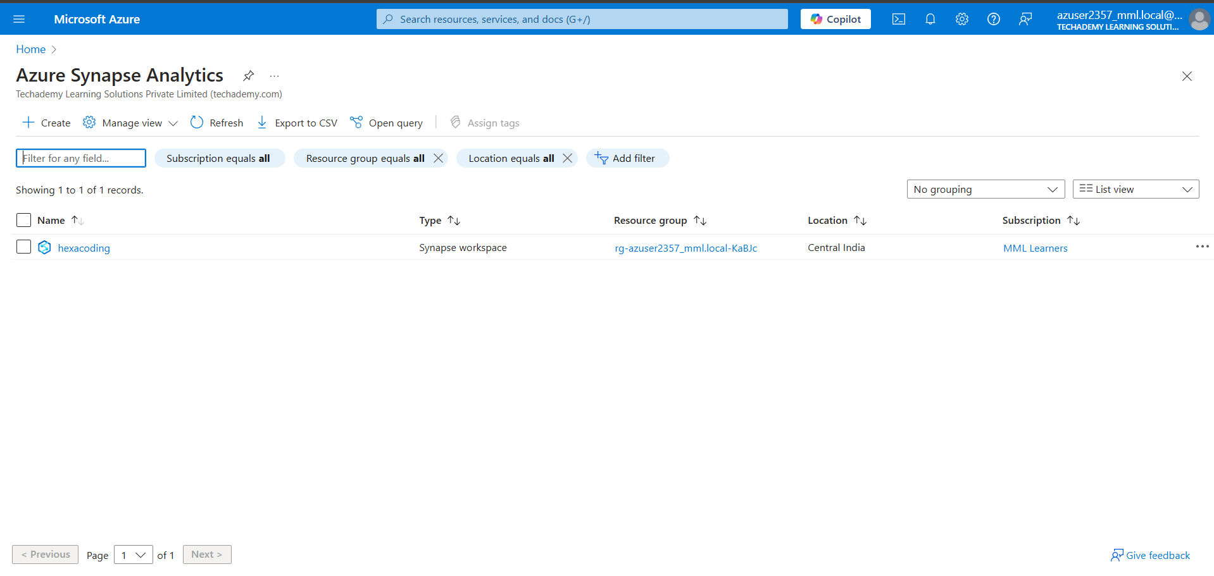

1. **Link the Data Lake Storage Gen2 Account**:

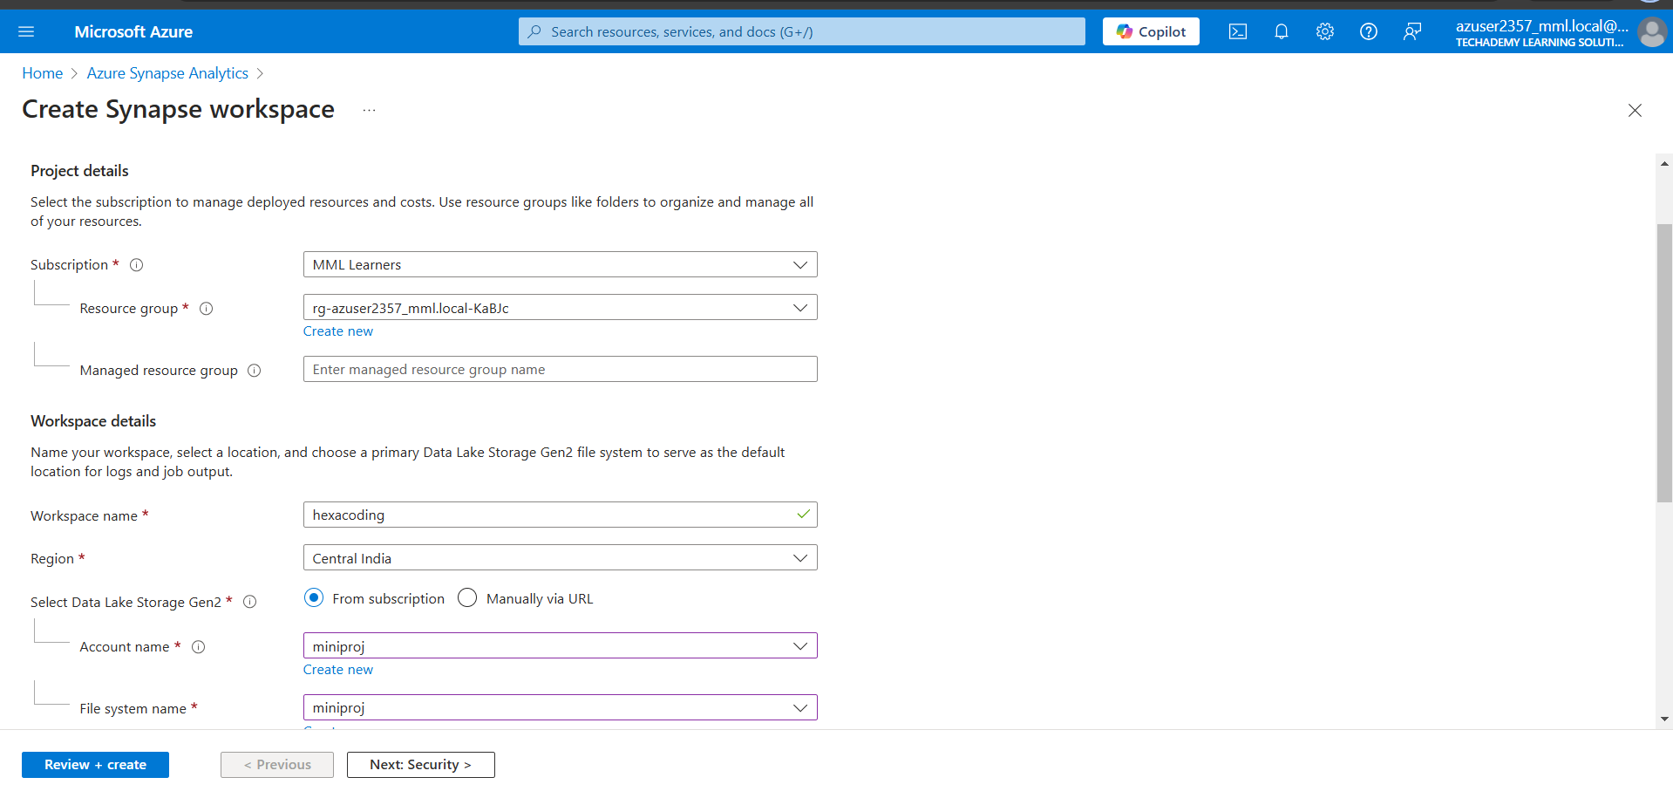

1. **Create a Pipeline in Synapse**:

* In Synapse Studio, go to the **Integrate** tab.
* Click on **+ New** and select **Pipeline**.

1. **Add a Copy Data Activity**:

* Drag and drop the **Copy Data** activity into the pipeline canvas.

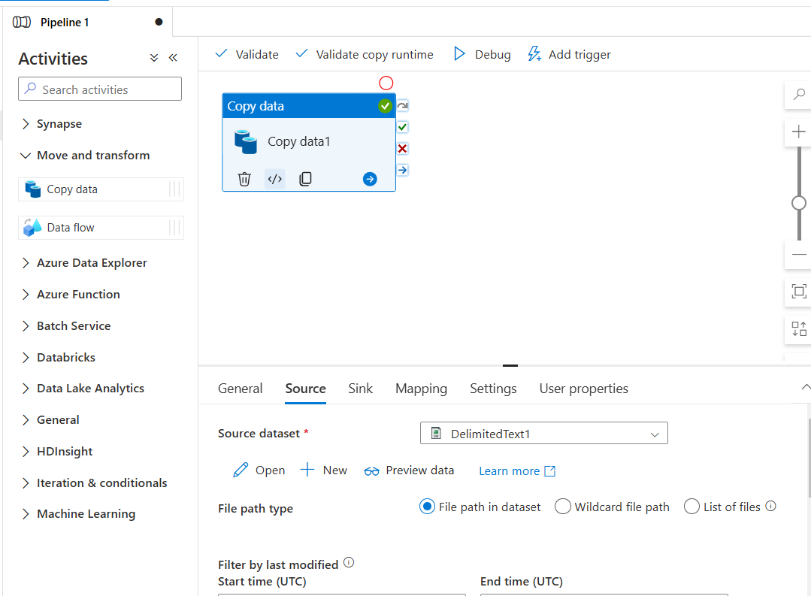

1. **Test the Pipeline**:

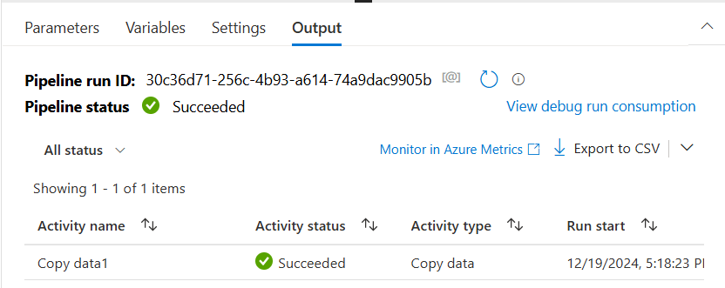

1. **Create the Dataflow**.

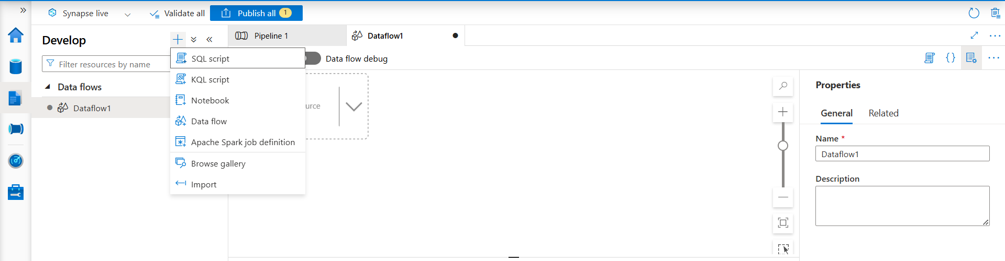

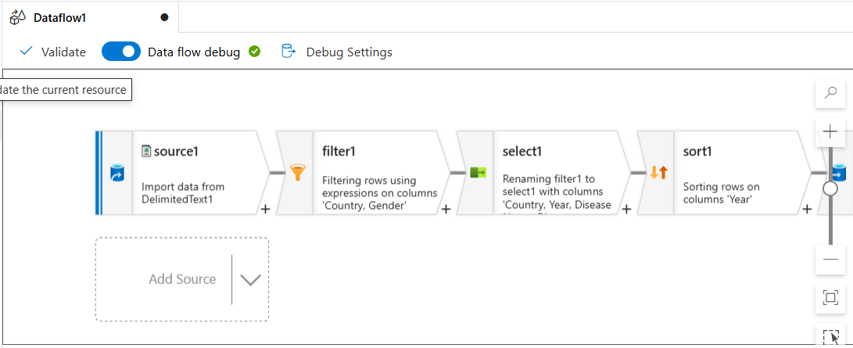

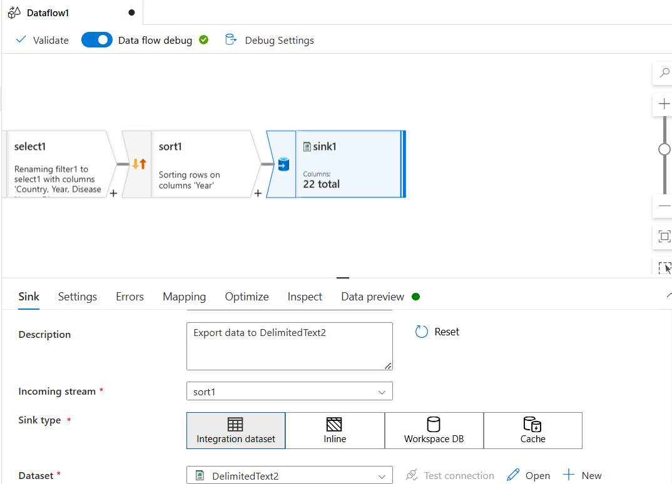

1. **Add a Dataflow Activity in the Pipeline:**

